

**Deep learning**

**Dr. Nitin Malik**

**Project Report**

**Topic: VIRTUAL MOUSE**

|  |
| --- |
|  |
|  |

**Department of Computer Science and Engineering**

**The NorthCap University, Gurugram- 122001, India**

**Session 2022-2023**

*Published by:*

Mukul

**VIRTUAL MOUSE**

**ACKNOWLEDGEMENT**

Before delving into the specifics of our project, We would like to express our sincere gratitude to all those who contributed in countless ways, and provided unwavering support from the very beginning.

We sincerely owe special regards to Dr. Shraddha Arora, The NorthCap University for their continuous encouragement and support during this entire project.

**ABSTRACT**

The paper proposes a method for using machine vision to track finger movement in real-time, by implementing an efficient color-based algorithm for gesture spotting. Hand gesture interpretation is a challenge in Human Computer Interaction (HCI), involving locating the boundaries of gestures in a video sequence and recognizing the specific gesture being performed. Current approaches use visual features extracted from individual frames, which can be inefficient due to variations in frames at different intervals. The paper introduces a new sub-gesture modeling approach that represents each gesture as a series of fixed sub-gestures, resulting in more robust modeling of visual features. The method is also expanded to gesture spotting using a filler model and a gesture completion model to identify the boundaries of gestures. The experimental results show that this method outperforms both state-of-the-art Hidden Conditional Random Fields (HCRF) based techniques and baseline gesture spotting approaches.

**Table of Contents**

**Topic………………………………………………………………page number**

|  |  |  |
| --- | --- | --- |
| I. | Acknowledgement -------------------------------------------------------------- | i |
| II. | Abstract --------------------------------------------------------------------------- | ii |
| 1. Introduction --------------------------------------------------------------------------- | | 6 |
| 2. Problem Statement --------------------------------------------------------------------- | | 7 |
| 3. Methodology ---------------------------------------------------------------------------- | | 8 |
| 4. Experimental Analysis ------------------------------------------------------------------ | | 9 |
| 5. Outputs ----------------------------------------------------------------------------------- | | 18 |
| 6. Conclusion ------------------------------------------------------------------------------ | | 21 |
| 7. References ------------------------------------------------------------------------------ | | 22 |

**INTRODUCTION**

"AI VIRTUAL MOUSE ," this project involves the development of a camera-based model for tracking hands, which can determine the position of a hand and its condition. By utilizing a single camera positioned at a considerable distance from the user, we have devised a method for tracking the 3D position of a finger. In addition, we present a new approach for implementing a virtual mouse using fingertip tracking, which allows users to control web pages through hand gestures. This system simulates mouse operations and enables users to navigate web pages using intuitive hand gestures.

In this project, we present a technique for implementing a virtual mouse based on fingertip tracking that simulates mouse operation through hand gesture and enables user-based hand gesture control of pages.

The project has hand tracking module containing fine Hands , fine position ,fine distance and finger Up method which the main code utilizes to perform actions to detect and track hand.

**Problem Statement**

The proposed AI virtual mouse with a hand signal interface may also be able to navigate obstacles inside of spaces where a real mouse cannot be used, as well as be set up for those who have gripping difficulties and don't seem to be able to utilise a real mouse. Since hand sign and hand Tip disclosure is used to control the device mouse limitations by utilising a camera or a typical camera like a webcam, the projected AI virtual mouse might similarly be adjusted to overcome these issues. A few specific components, such as the mouse, the device to connect with the computer, and aside from the battery to power the mouse, are required when utilising a remote or a Bluetooth mouse to manage a used As a result, the client controls the PC mouse activity throughout by using his or her natural camera or visual camera as well as hand movements.

**Proposed Methodology**

The program when launched will open the camera and start to take input. Once a hand comes in the range of the camera it will use mediapipe to mark 21 landmarks (3 on each finger 1 at every finger joint and 2 on the palm) on the hand of the user, using the coordinates of the finger we will determine which finger is up, if only index finger is up the program will go in move mode, in which it will track the tip of the index finger and move the mouse with the movement in of the finger. If both Index and the Middle finger is up, the code will go in click mode, when the distance between the Index finger and Middle finger is less then 40 pixel, mouse will be clicked.

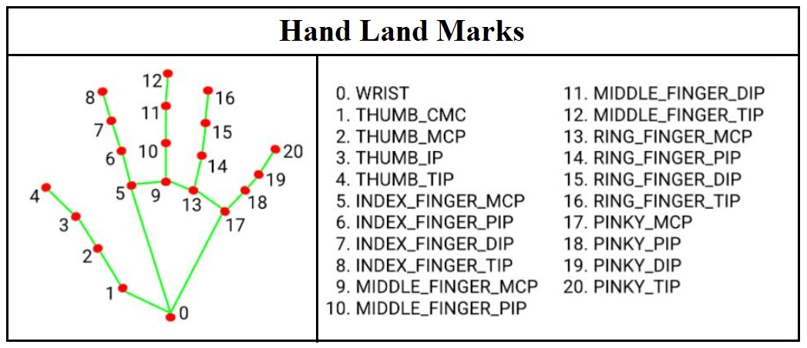

**Experiment Analysis**

**Hardware Requirement**

CPU – Ryzen 5 4600h

GPU – Nvidia GTX 1650

RAM – 8GB

Python – Version 3.7

Webcam

**Software Requirement**

PyCharm CE

Python 3.7

AutoPy 4.0.0

MediaPipe 0.8.8

**Tech Stack Used**

1. **OpenCV:** The programming functions in the library are primarily designed for real-time computer vision applications.
2. **MediaPipe:** The framework is designed to construct machine learning pipelines that handle time series data, such as audio and video.
3. **AutoPy:** This is a Python library that provides a user-friendly, cross-platform Graphical User Interface (GUI) automation solution. It includes various functions that allow for the control of keyboard and mouse actions.

**Steps of implementation**

1. Find hand landmarks

2. Use fingersUp() method to find which figure is up (Index, Middle)

3. If only index figure is up, Moving mode

* Convert Coordinates
* Smoothen the values
* Move mouse with the hand

4. Both Index and middle fingers are up, Clicking Mode

* Find distance between index and middle figure
* Click mouse if distance short (less than 40 pixel)

**Working of code**

All the libraries used in the project

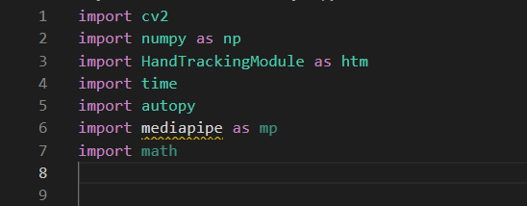

***(Fig 1.1: Libraries Imported in code)***

**HandTrackingModule.py**

**handDetector class:**

mode = false means for some times it will track/Predict and for some times it will detect (dectectionCon = 0.5 means it will detect the hand if the confidence is 50% or more) based on the confidence level, if we won't make mode = false, it will always detect which will require high processing power and will make the code execution slow.

**Method findHand:**

Converting BGR to RGB because hands module takes RGB image

hands.process will process the image and will give us the results, it returns <class 'mediapipe.python.solution_base.SolutionOutputs'>

If there is a hand in the camera mediapipe method will draws 21 landmarks on the hand (3 on each figure and one at every figure joint and 2 on palm).

self.mpHands.HAND_CONNECTIONS will draw connections between the landmark

And finally, this method will return image with landmarks.

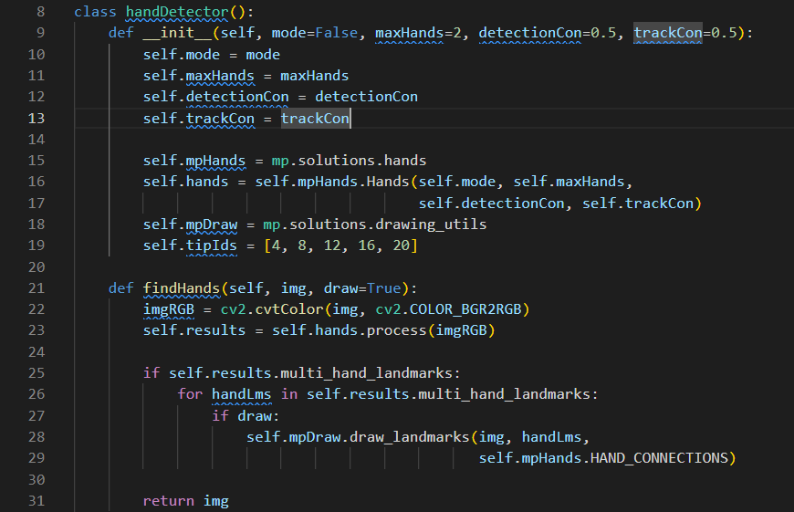

***(Fig 1.2: Function to detect hand points)***

**Method FindPosition:**

We are taking only the 1st hand in the list multi_hand_landmarks[]

(lm) landmark information has x, y coordinates, and (id) id number for each landmark, in sequence # enumerate uses counter as a key (it will use 0,1,2... as key) to store/traverse... , so we can use it to get the id number.

cx and cy are the coordinates of the landmarks # lm.x and lm.y are the coordinates of the landmarks in percentage, of the img size, we need to multiply

them with the width and height of the image to get the actual coordinates in pixels.

appending the x,y coordinates of the landmarks to the list

using the minimum, maximum coordinates of x and y draw a rectangle around the hand.

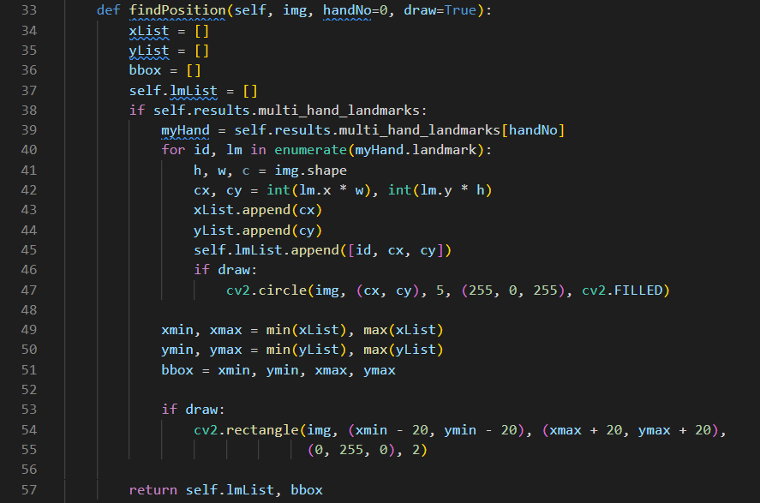

***(Fig 1.3: Function to detect position of hand points)***

**Method FingersUp**

This method returning a list (fingers[]) of fingers that are up.

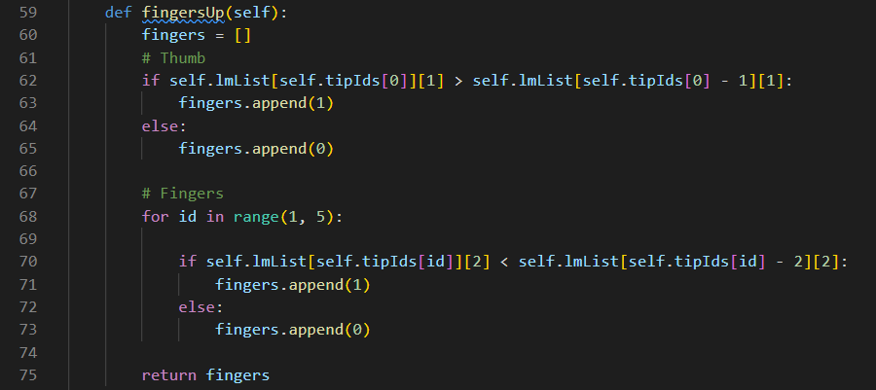

***(Fig 1.4: Function to detect movement of fingers***

**Method findDistance:**

x1, y1 are the coordinates of the first point (Index fingertip)

x2, y2 are the coordinates of the second point (Middle fingertip)

cx, cy are the coordinates of the center of the line between the two points

Draw circle on index and middle finger and draw line between them with a point in between.

length give distance between the fingers

All of these variables with the changed image, have a circle on index, middle fingertip and a circle in between them is returned when this method is called.

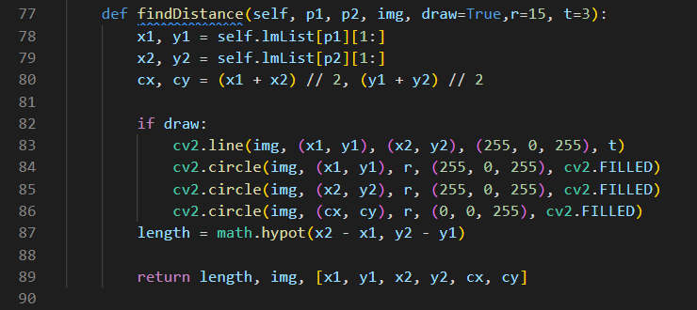

***(Fig 1.5: Function to detect distance of fingers from camera)***

**Main Method:**

Opening camera and taking images as input from it

Print frames per second on the screen using cv2

And method calling

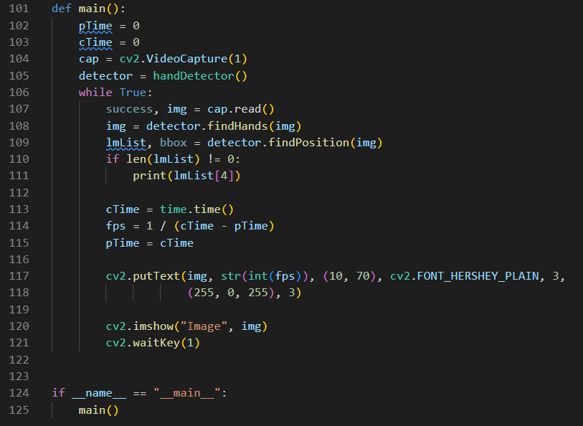

***(Fig 1.6: Main function)***

**AIVirtualMouseProject.py**

Opening the camera using OpenCV, specifying the width and height of the camera with reduced frame rate of 100fps and Making object of handDetector class.

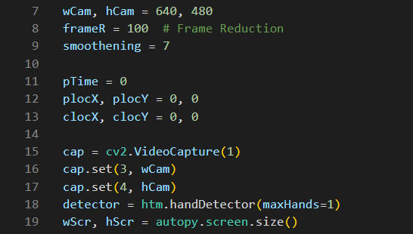

***(Fig 2.1: Opening Camera)***

Find position of hand using findHands method in HandTrackingModule

When lmList (elements in format [id, cx, cy]) is not empty, get the coordinates of the tip of the index finger and middle finger

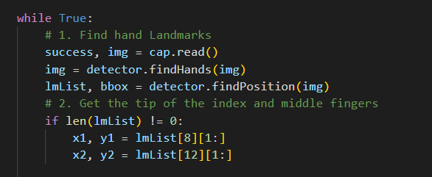

***(Fig 2.2: Using Function findHands )***

When only the Index finger is up: Moving mode

draw a rectangle for range of motion in which the mouse will move (Consider this as trackpad area)

Convert the coordinates of the tip of the index finger according to the screen size

Smoothen Value--------------------------------------

Move the mouse according to the coordinates of the tip of the index finger (wScr - clocX, clocY)

when in moving mode, draw a circle on the tip of the index finger

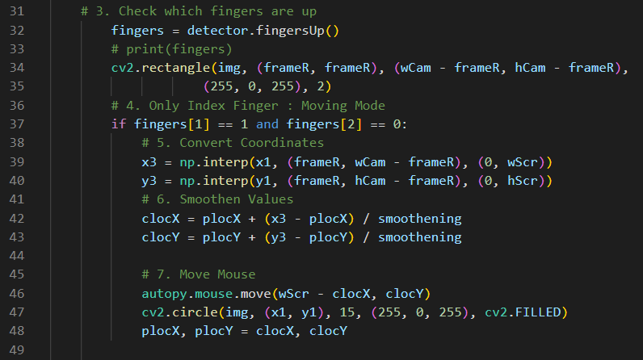

***(Fig 2.3:When Only One Finger Is Up)***

Both Index and middle fingers are up: Clicking Mode

Find distance between Index and Middle finger, when the distance between the tip of the index finger and the tip of the middle finger is less than 40, draw a circle in between the fingers and click the mouse

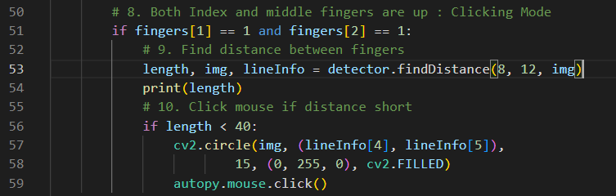

***(Fig 2.4:Clicking Mode)***

Time is taken to complete all the operations, so when the code reaches the end, calculate the time used to complete the loop (cTime - pTime) and calculate the frame rate, Print it on the screen.

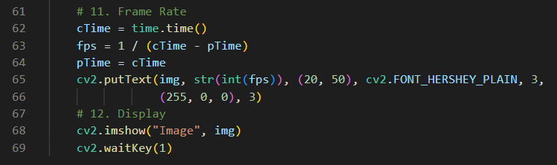

***(Fig 2.5:Calculating Frame Rate)***

**OUTPUTS**

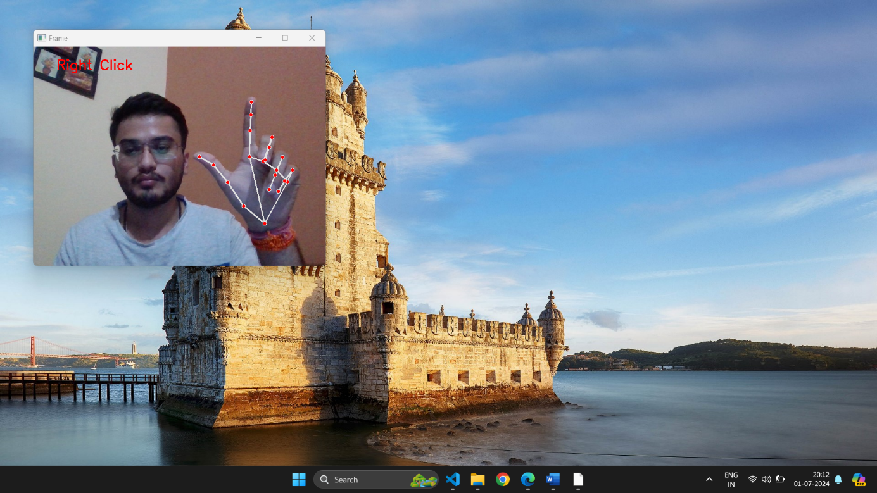

***(Fig 3.1:Hand Tracking)***

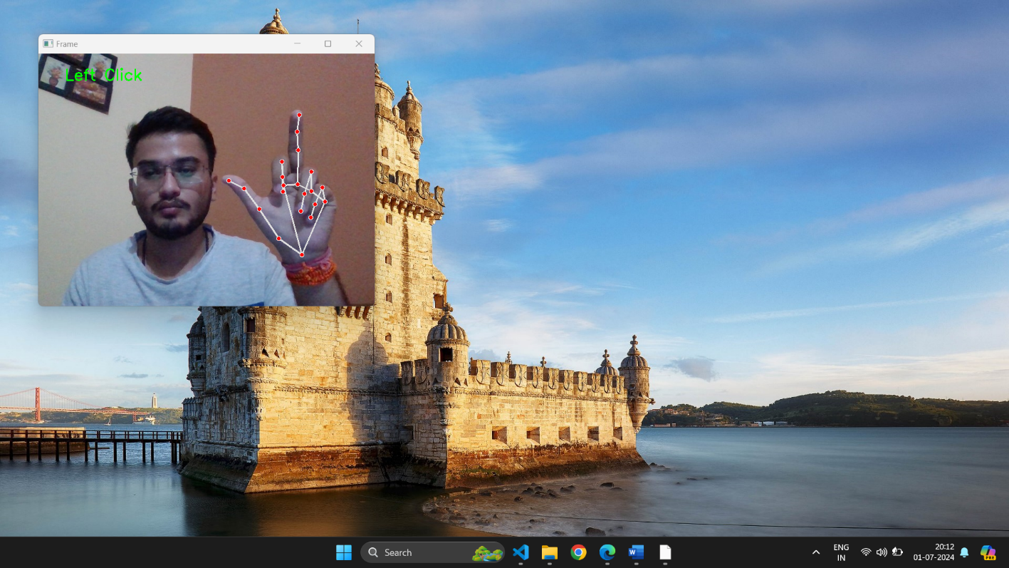

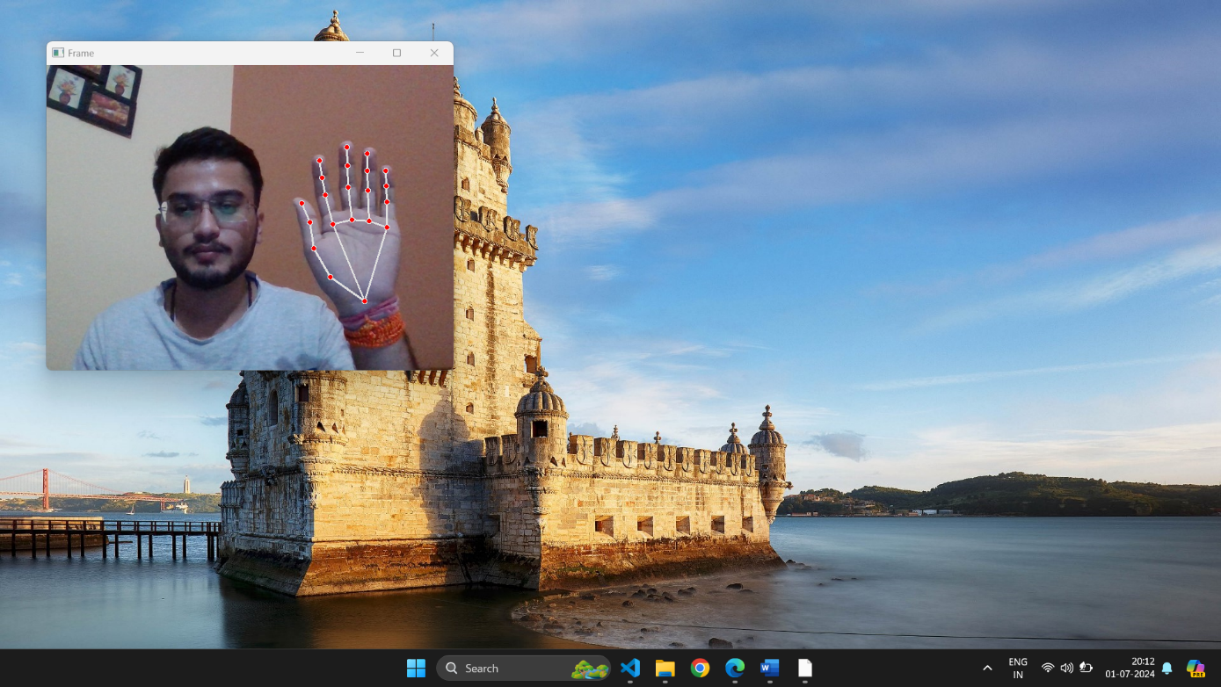

***(Fig 3.2:Moving Mode)***

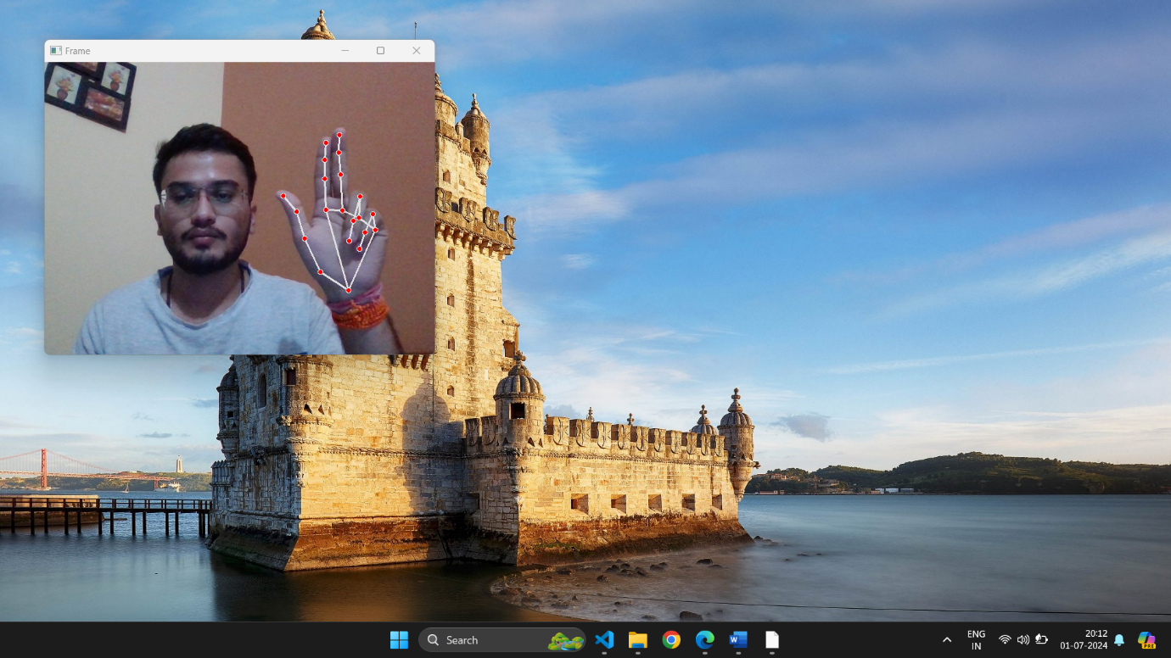

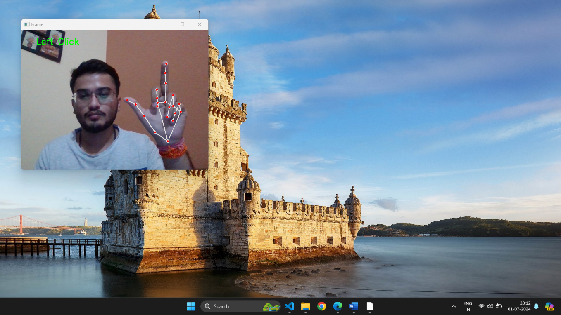

***(Fig 3.3:Clicking Mode)***

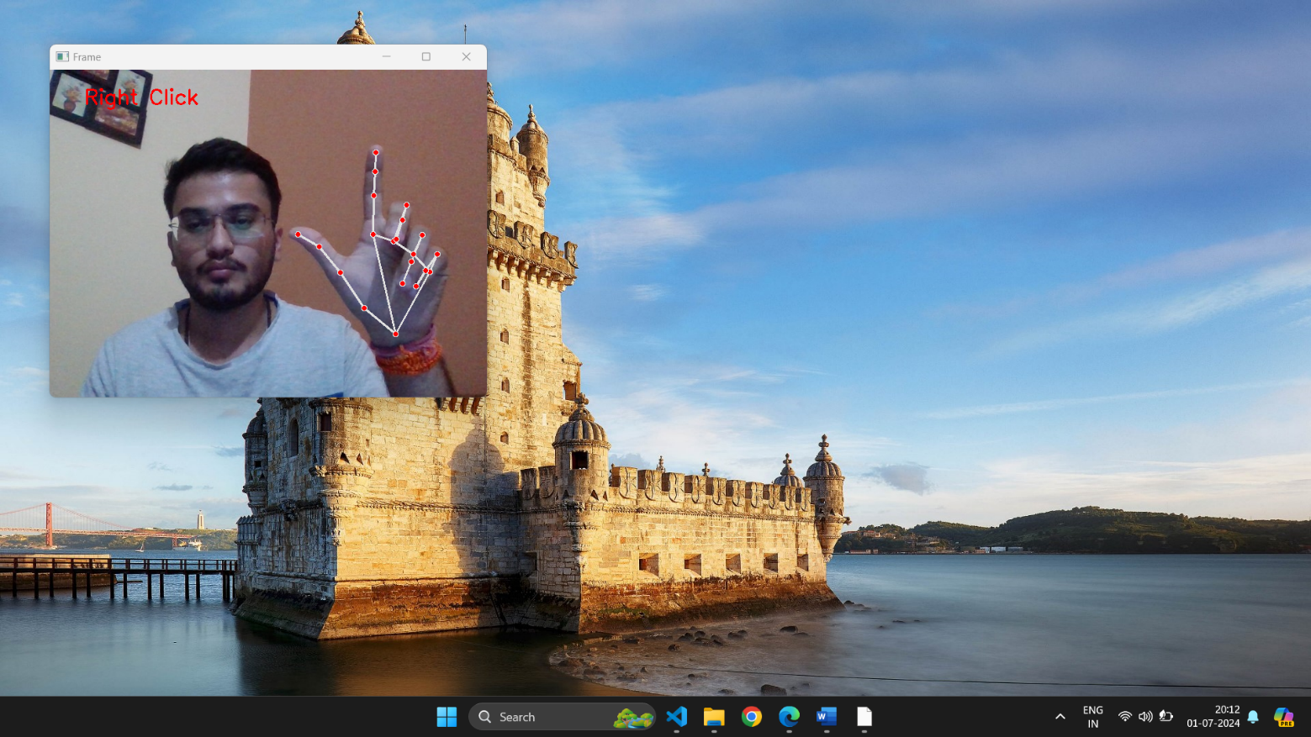

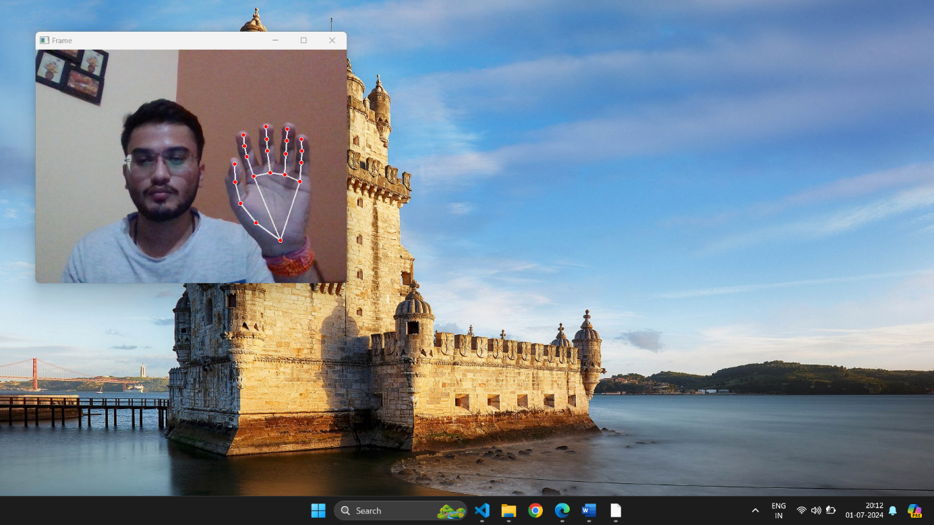

***(Fig 3.3:Final Clicking Mode***

**CONCLUSION**

This Project introduces a novel virtual-mouse technique based on fingertip detection. Without using a mouse, gloves, or markers, the user interacted with the computer by moving their fingertip in front of a camera. The method showed off not only extremely precise gesture estimates but also useful applications.

The proposed approach gets around the drawbacks of the majority of existing virtual-mouse systems. It has several benefits, including accurate fingertip tracking at a greater distance and with complicated backgrounds. The results of the experiments showed that this method is a promising one for real-time fingertip gesture interfaces.

Multiple restrictions that are primarily carried over from Microsoft Kinect continue to plague this study. Our upcoming study tries to get over those restrictions and enhance the fingertip tracking algorithm. Additionally, we want to develop our technology so it can work with more gestures and other intelligent surroundings.

**BIBLIOGRAPHY**

1. **Research on Optimization of Static Gesture Recognition Based on Convolution Neural Network.**
2. **Gesture Recognition using Open-CV**

# **Recognition of gestures using morphological features of networks made of gesture motion images and word sequences.**

# **Hand Gesture Recognition using Deep Root Nodal Architecture (DRONA)**

1. **Real-Time GestureRecognition by Learning and Selective Control of Visual Interest Points**

# **Hand gesture recognition using deep learning**

# **Head Gesture Recognition System Using Gesture Cam**

# **A Method for Hand Gesture Recognition**

# **Design of control system based on hand gesture recognition**

# **Numeral Gesture Recognition Using Leap Motion Sensor**